Squirrel, Bird and Nature Photo Workshop
Amazing location with Red Squirrels, Birds and forest!

More!
Amazing location with more eagles than you can count!
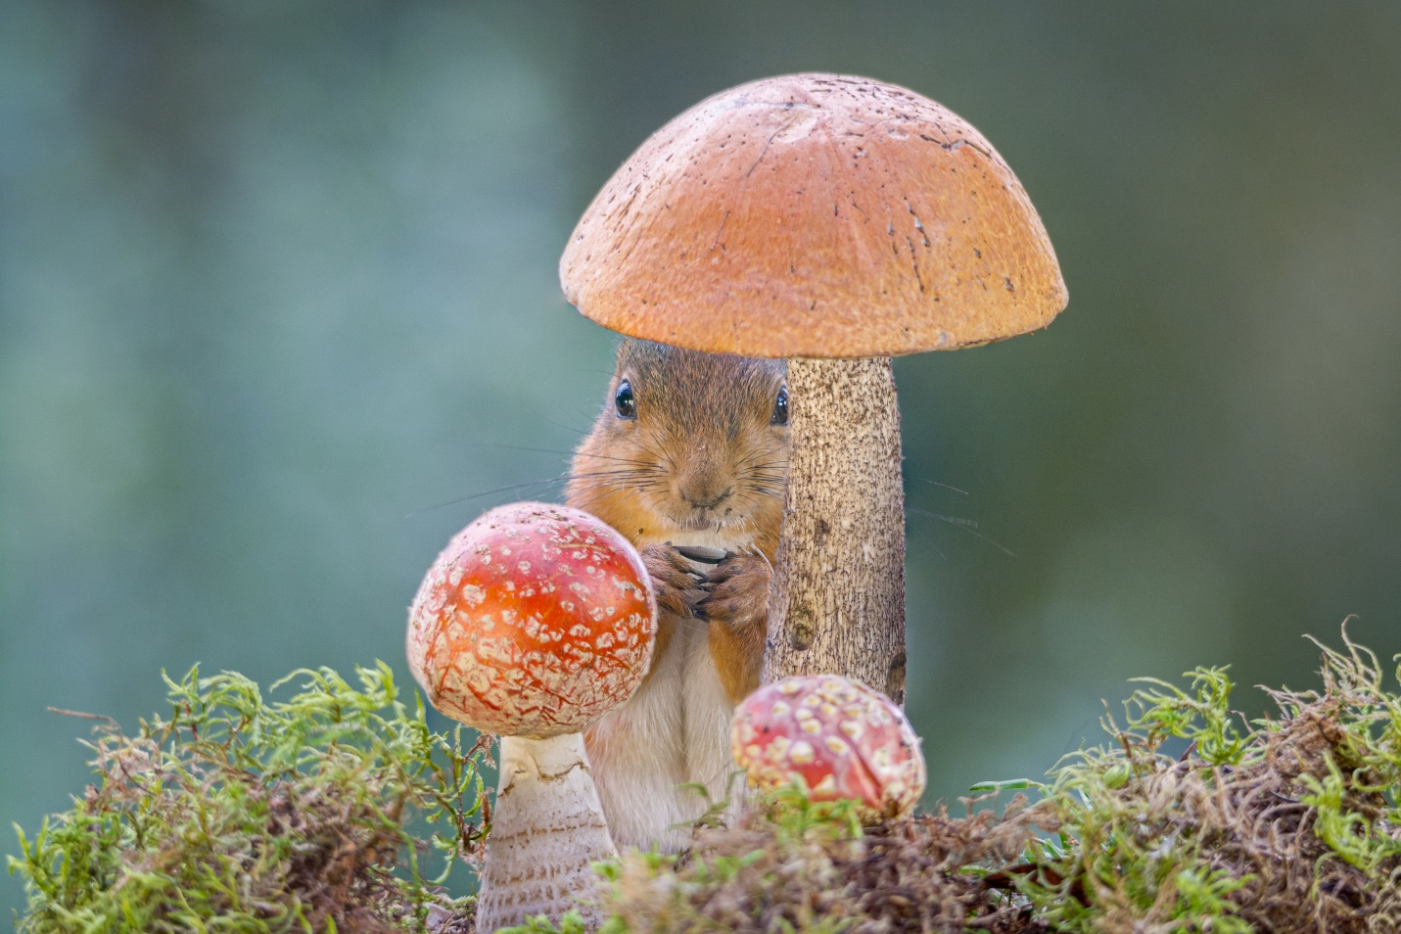
Duration: 5 days (possibility to discuss workshop dates and more workshop days)
Location: Bispgården, Sweden
Price: 650 euro (5 days workshop)
The red squirrel has become iconic in animal photography; they make interesting and gentle moves. Capture them in your camera in this incredible unique Red Squirrel, Bird and Nature Photo Workshop. This workshop coincides with Red Squirrels and birds living in the middle of Sweden. Between 3 and 10 wild Red Squirrels incl. young ones can show up during this workshop in an outside studio and you’ll be there to photograph these majestic animals.

Prepare to be AMAZED!
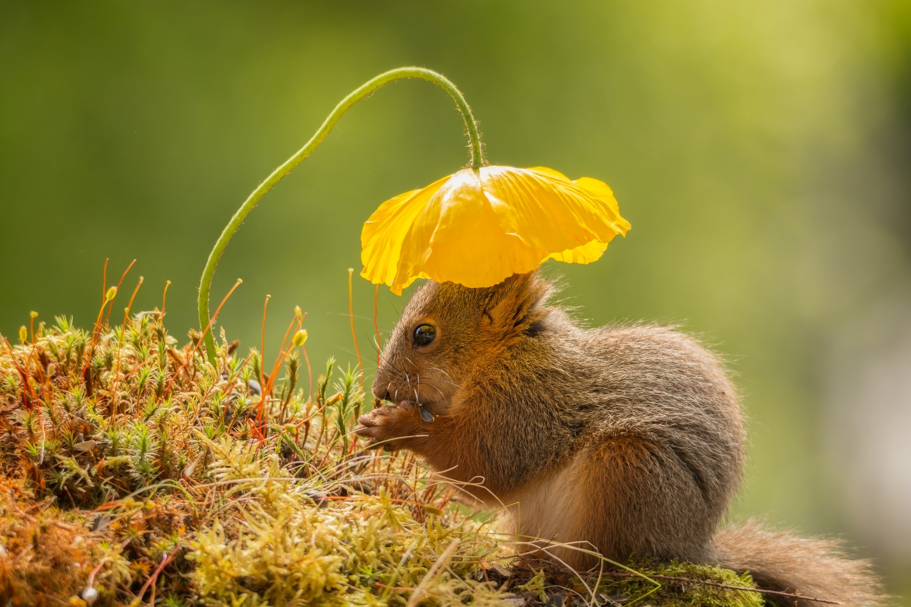
Sun head –Young red squirrel under a poppy flower

Workshop Overview
- Red Squirrels and Birds in nature scenes and with props
- Small Group – max 2 participants
- 4 nights and 5 days with possibility to plan more days
- New! Possible to extend with 150 euro a day.

Included in the Workshop
Lunch and drinks while on location.
Not included travel costs, accommodation, dinner and lunch, travel insurance, alcohol, items of personal nature.
Accommodation
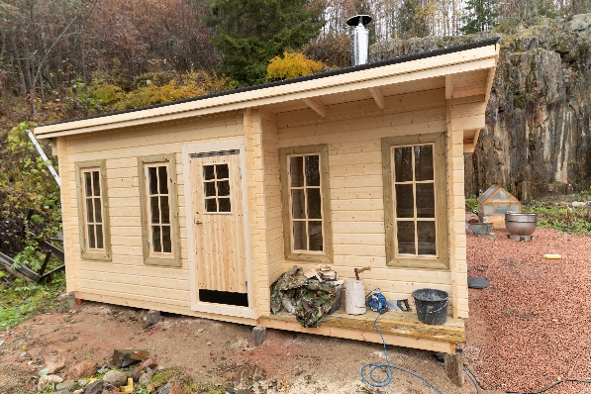
There is a possibility to rent my little guesthouse with sauna, for 35 euro for each night incl. dinner and lunch.
The kitchen and shower you have to use from my house.
There is a wonderful room for rent 20 minutes from my home. Also is there place for free camping 10 minutes distance from my house.

Props
Tools available to create your own props. I encourage you to bring your own miniature props.
Macro and Landscape photography
If you decide to expand this workshop with more days, this location is a paradise for the photographers who want to photograph Macro or Landscape within this workshop.
It is limited to 2 photographers so you can count on minimal interruption throughout your workshop.
I will help you with your camera settings, photography techniques and process tips if needed.
During the workshop, we will gather with our laptops and discuss editing techniques to achieve sharper images, composition from cropping and introduce you to some techniques we use to create images that are more appealing.
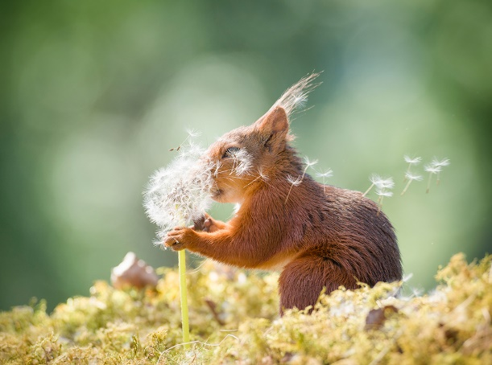
Wishes

Itinerary
Day 1 We will meet at 9.00, and begin with a short introduction and start to set up. We focus on finding the right light, positions and spent time knowing the behavior of the animals.

Day 2 This day we concentrate on compositions and props.

Day 3 A day where we photo with different pov and coming closer to the animals.

Day 4 Day of challenge. Action, self-portraits with the squirrels and multi exposures with squirrels.

Day 5 Day of choice. We as a group decide where to focus on. It can be landscape, art, bird, macro photography or continue to do more squirrel photography. 17.00 is the end of the workshop.

Equipment and Gear
Be prepared for temperatures between 0 and 50 F (5 to10 C in the night). If is rainy we still can take pictures under a roof.
This is a workshop for the big and small lenses, a minimum of 200 mm, later on during the workshop we can use 50 mm or less. A sturdy tripod with a gimbal head will be invaluable. Do bring your high-speed flashes with remotes and props if you have.
You will take more images than you might expect so be sure you are loaded up with memory cards, extra battery and computer.
It’s almost impossible to list everything that you’ll need, get in touch and we can talk about what you have and what you might need.

Final Thoughts
5 days is short, but enough to capture wonderful, magical photos. The squirrels and birds life in the forest and normally they show up every day, but there is never a guaranty.
You need to take care for your own travel. Best is to come with your own car or rent one.
As soon, you paid 200 euro in advance the date is booked the rest (450 euro) need to be paid 4 weeks before the workshop.
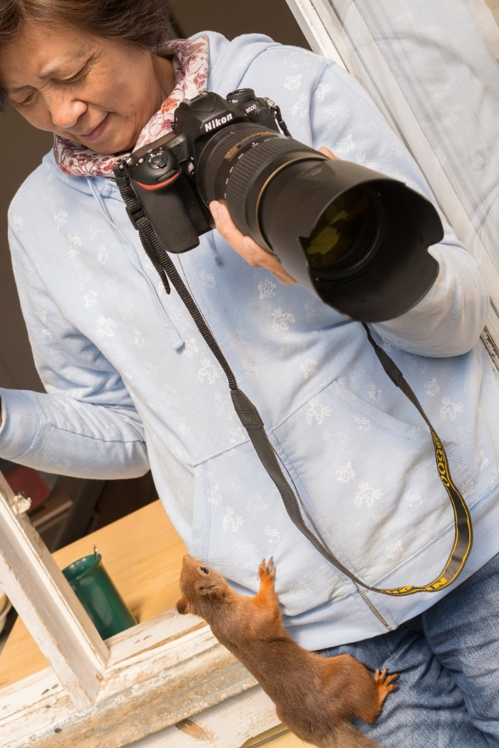
Liping participant from a workshop

Ready To Go?
You can reserve your workshop with a 200 euro deposit (not refundable). After the date conformation I sent you my bank details. Your final payment need to be 4 weeks before the workshop.

How to travel

Rent a car: This is the best option. You can rent a car in Stockholm, Östersund or Sundsvall.

Take a bus: Closest airfields are Sundsvall and Östersund from there are buses to Bispgården. There are not many buses during the weekend that is why the workshops start and end during a weekday.

Train: There are trains going to Östersund and Sundsvall as well. From here you can rent a car or take a bus.

Hotel/ Guesthouse
There are many options. Here are some alternatives:
https://www.lodgelagom.com/
https://wildernessadventuressweden.com/en/
https://hotellindalsleden.se/
http://www.alggardsberget.se/
http://ragundadalen.com/portfolio-item/gerabadets-camping/

Location
Geert Weggen Björkstigen 3
84441 Bispgården Sweden
0046 (0) 768492056
geertweggen@yahoo.com
www.geertweggen.com

Bank details
Geert Weggen
Swedbank
Prästgatan 21, 831 31 Östersund
Territory: 006 Jämtland, Sweden
Bank account number: 924 426 230-0
IBAN SE5780000814719244262300
BIC/ SWIFT CODE: SWEDSESS
Tel 063-14 25 00

Paypal: geertweggen@yahoo.com

